**Low Cost Telematics Device Design Flow and Methodology**

# Table of Contents

**Table of Contents** **1**

**Component Selection** **2**

Inertial Measurement Unit (IMU 6 DOF): STMicroelectronics- ASM330LHHXTR 3

Global Positioning System (GPS) module: Ublox-NEO-M8Q-01A 3

Temperature and Humidity sensor: Sensirion-SHT 30 A 4

Low dropout regulator: AZ1117H 4

Microcontroller Board: Raspberry Pi Pico 5

Antenna for GPS: Active Antenna 5

**2) Design Methodology** **5**

Power Management 7

Interfacing Components 7

Data Storage 8

**3) Device Placement** **9**

**4) PCB Design Flow** **10**

**5) Purchase list** **12**

# Component Selection

The following Components have been selected to be included for the development of the low-cost telematics device. All the components benchmarked are of automotive grade and comply with AEC-Q100 standards, except for the microcontroller board due to unavailability of the automotive grade MCUs.

The benchmarked data, where I have benchmarked the selected components (in green font) with the existing market competitors and VBOX 3i-dual antenna is: s

The components selected are:

## **Inertial Measurement Unit (IMU 6 DOF): STMicroelectronics- ASM330LHHXTR**

Reasons for selection:

* Relatively lower random walk and noise density compared to other IMUS in the segment.
* Comparable bias instability(drift) with other IMUs benchmarked.
* Maximum output data rate of 6.7 KHz, highest among competitors.
* More cost effective compared to other IMUs.
* This IC has recently been launched from STMicroelectronics and hence has a longer product cycle.

Datasheet: [Datasheet - ASM330LHHX - Automotive 6-axis inertial module with embedded machine learning core and dual operating modes (st.com)](https://www.st.com/resource/en/datasheet/asm330lhhx.pdf)

Purchase link: [ASM330LHHXTR STMicroelectronics | Sensors, Transducers | DigiKey](https://www.digikey.in/en/products/detail/stmicroelectronics/ASM330LHHXTR/16399064)

## 

## **Global Positioning System (GPS) module: Ublox-NEO-M8Q-01A**

Reasons for selection:

* Highest number of channels (72) compared to competitors increasing the precision achieved by the receiver.
* Lowest Time to first Fix( Cold start time) i.e the time elapsed from when the GNSS receiver is switched on until the output navigation data is received (<26 seconds for this GPS module).
* Low power consumption of 67 mW.

Datasheet: [NEO-M8Q-01A (u-blox.com)](https://content.u-blox.com/sites/default/files/NEO-M8Q-01A_DataSheet_%28UBX-15013820%29.pdf)

Purchase link: [NEO-M8Q-01A U-Blox | RF/IF and RFID | DigiKey](https://www.digikey.in/en/products/detail/u-blox/NEO-M8Q-01A/9817999)

## **Temperature and Humidity sensor: Sensirion-SHT 30 A**

Reasons for selection:

* Wide range to measure relative humidity from 0% to 100% with a high accuracy of ±3 %RH.
* Measures Temperature over a range of −40°C to +125°C with a high accuracy of ± 0.3 °C.

Datasheet: [Sensirion_Humidity_Sensors_SHT3xA_Datasheet.pdf](https://sensirion.com/media/documents/68C84E66/61641CAE/Sensirion_Humidity_Sensors_SHT3xA_Datasheet.pdf)

Purchase link: [SHT30A-DIS-B2.5KS Sensirion AG | Sensors, Transducers | DigiKey](https://www.digikey.in/en/products/detail/sensirion-ag/SHT30A-DIS-B2-5KS/11634602)

## **Low dropout regulator: AZ1117CD**

Reasons for selection:

* Provide regulated output voltage of 3.3V,1A to all the components for operation, taking an input voltage of 5V, 3A from the car's USB charger.
* Very Low Dropout Voltage.

Datasheet: [AZ1117C (diodes.com)](https://www.diodes.com/assets/Datasheets/AZ1117C.pdf)

Purchase link: [AZ1117CD-3.3TRG1 Diodes Incorporated | Integrated Circuits (ICs) | DigiKey](https://www.digikey.in/en/products/detail/diodes-incorporated/AZ1117CD-3-3TRG1/4470979)

## **Microcontroller Board: Raspberry Pi Pico**

Reasons for selection:

* Cost effective microcontroller board available with multitude of interfaces like SPI, UART, ADC, I2C available for interfacing sensors and components.

Datasheet: [Raspberry Pi Pico Datasheet](https://datasheets.raspberrypi.com/pico/pico-datasheet.pdf)

Purchase link: [SC0915 Raspberry Pi | Development Boards, Kits, Programmers | DigiKey](https://www.digikey.in/en/products/detail/raspberry-pi/SC0915/13624793)

## **Antenna for GPS: Active Antenna**

Reasons for selection:

* To enhance the strength of the received signal to the GPS Receiver module.

Datasheet: not available

Purchase link(not available on digikey.in):[28db High Gain Built-in Ceramic Active GPS Antenna for NEO-6M NEO-7M NEO-8M buy online at Low Price in India - ElectronicsComp.com](https://www.electronicscomp.com/28db-high-gain-built-in-ceramic-active-gps-antenna-for-neo-6m-neo-7m-neo-8m?gclid=CjwKCAjwmJeYBhAwEiwAXlg0ATsQmh_qVYTUq7gcVFSizzbe980m5XvuzNwPswAM9NIP5X0ItMY7YhoCawEQAvD_BwE)

# 2) Design Methodology

The design methodology is as follows:

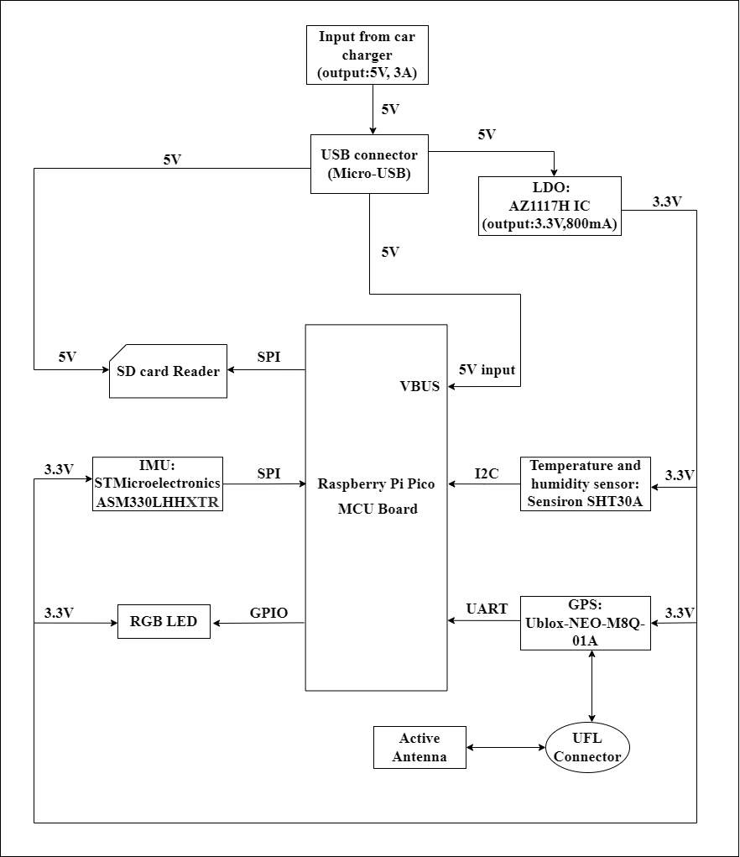

The Methodology can be broken down into 3 major aspects:

## Power Management

## Power source will be the car charger with an output of 5V, 3A. The designed PCB will have a mini USB connector for connecting to the car charger and powering the telematics device.

## Raspberry pi pico has a maximum operating voltage of 5.5V and hence it can be powered by the 5V of the car charger,via USB. The connection will be made to the VBUS pin of raspberry pi pico which is the micro-USB input voltage, connected to the Micro-USB port of the pico.

## The sensors and components typically operate between 1.8-3.6V, to have them functioning we connect AZ1117CD IC to the output from the USB, converting the 5V to 3.3V and producing an output current of 800mA.The Micro SD card module (operating range: 4.5-5.5V) will be powered using the 5V connection from the Micro-USB connection.

## The reason to use a standalone IC and not power the components from the microcontroller is because the IC has a very low dropout voltage and will provide a stable output voltage to the components.

## Interfacing Components

* An OLED Display will be used for indicating various scenarios or instructions. Some scenarios are as follows:

1. Instructing user to start recording by pressing respective button
2. Indicate when Data is being is being recorded
3. Display all the GPS coordinates, speed and acceleration.

* The 6DOF IMU will be interfaced over SPI protocol with the microcontroller, for receiving the accelerometer and gyroscope readings. SPI protocol is used for its ability to perform high speed data transfer and its low power operating capability.
* The GPS receiver module will be interfaced over the UART protocol with the microcontroller for receiving the latitude and longitude data. The GPS module will be connected to a male UFL connector on the PCB. It will be used for connecting an active antenna to the GPS receiver, which will enhance the strength of the received signal, suitable for our applications where latency and loss of data can be deleterious.
* Temperature and Humidity sensor will be interfaced over the I2C protocol with the microcontroller for measuring and storing the temperature and humidity of the indoor car environment. It will be used to determine any anomaly in the operation of the telematics device due to extreme variation of temperature or humidity.

## Data Storage

* All the data from the sensors will be stored in a 32GB micro SD Card in CSV (comma-separated values) format making it advantageous for post processing the data. The micro SD card will be placed in a micro SD card reader module interfaced over SPI protocol with the microcontroller.

# 3) Device Placement The recommended placement of GPS receiver antenna by the manufacturer (UBLOX) is as follows:

In accordance with the needed requirements, the device will be placed on the dashboard.

The recommended placement of the Ceramic Active antenna on the PCB substrate suggested by the manufacturer is as follows:

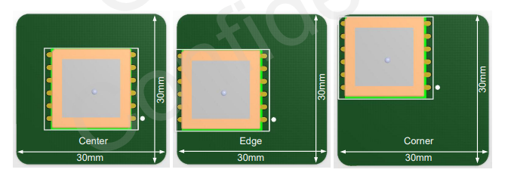  
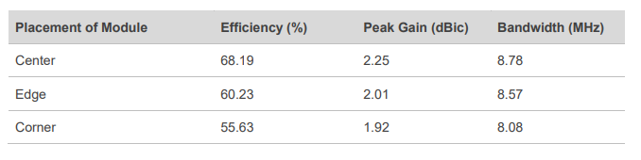

# Considering the guidelines and the requirements of the device. The device is proposed to be attached to the car AC vents as follows: The housing will have openings for the Screen, user button, toggle(ON/OFF) switch and the active GPS antenna at the top of the device. 4) PCB Design Flow Taking into consideration, the placement of the the device in the car and the guidelines stated by the GPS manufacturer (UBLOX), the PCB design flow is as follows:

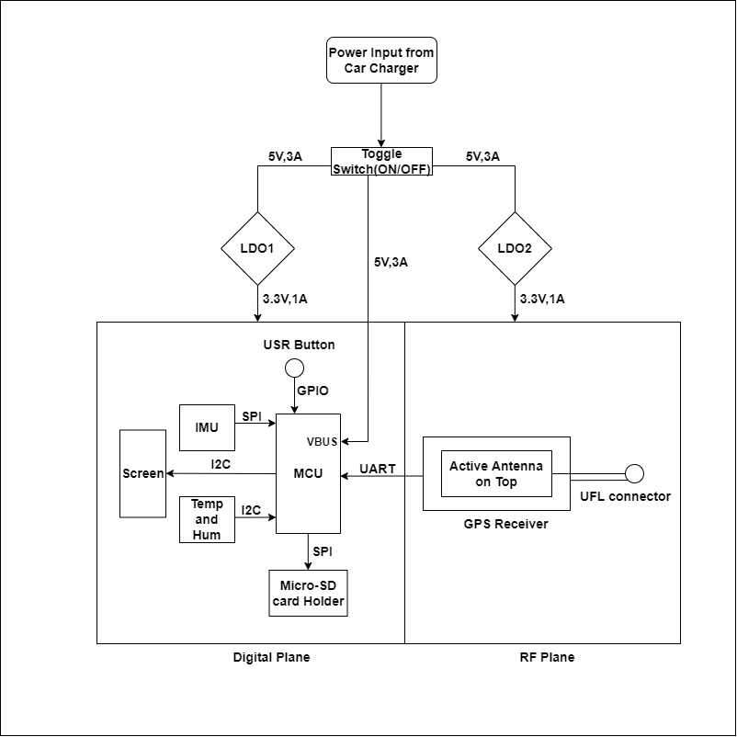

# The designing shall be done keeping the following key points into consideration:

1. The PCB will be divided into the digital plane (sensors, microcontroller and screen) and RF plane (consisting of GPS module and antenna), with different ground planes for each plane to prevent interference from the RF components of the device to the digital components and making it conducive for debugging.
2. Two different low dropout regulators (LDOs) for each plane for debugging. If the design proposed works without any issues, the second LDO can be removed.
3. The active antenna connected to the UFL connector will be placed on the top of the GPS receiver module, in a separate housing and the digital components will be shielded to prevent any interference from the RF components.
4. An ON/OFF switch to switch on the device once being powered on.
5. A User button to start and stop recording the data by the user.

# 

# 

# 

# 5) Purchase list All the components have been selected from digikey.in. Components not available on digikey.in have been mentioned separately.

|  |  |  |  |  |  |
| --- | --- | --- | --- | --- | --- |
| **Component Name** | **Description** | **Price per component(₹)** | **Quantity** | **Cost(₹)** | **Purchase link** |
| Ublox-NEO-M8Q-01A | GPS receiver module | 1,997 | 5 | 9,985 | [Link](https://www.digikey.in/en/products/detail/u-blox/NEO-M8Q-01A/9818051?cur=INR&lang=en&utm_adgroup=RF%2FIF%20and%20RFID&utm_source=google&utm_medium=cpc&utm_campaign=PMax%20Shopping_Product_RF%2FIF%20and%20RFID&utm_term=&productid=9818051&gclid=CjwKCAjw0dKXBhBPEiwA2bmObWNZqGQRw1kqL0DJz_xgrt3ITRvpIhk72hBaPyG69nHEagqXBytGgRoCKtgQAvD_BwE) |
| STMicroelectronics ASM330LHHXTR | IMU(6DOF) | 1,392 | 5 | 6,960 | [Link](https://www.digikey.in/en/products/detail/stmicroelectronics/ASM330LHHXTR/16399064?s=N4IgTCBcDaIMoBUCyBLAxgJwPYFMA2OaALtgHboDOABAIJxIDMDADADIAS7AGggEogBdAL5A) |
| Sensirion: SHT 30 A | Temperature and humidity sensor | 600 | 5 | 3,000 | [Link](https://www.digikey.in/en/products/detail/sensirion-ag/SHT30A-DIS-B2-5KS/11634602) |
| Raspberry Pi Pico | Microcontroller board | 319 | 5 | 1,595 | [Link](https://www.digikey.in/en/products/detail/raspberry-pi/SC0915/13624793) |
| Micro SD Card Reader Module | Micro SD card reader | 37 | 5 | 185 | [Link](https://www.electronicscomp.com/micro-sd-card-module-india?gclid=CjwKCAjwmJeYBhAwEiwAXlg0Aff7y04NVBQGDm19ui4r4NleSodH1Nz_9mWD1elao2q6_56Y2yiuNRoCLq0QAvD_BwE) (not available on digikey.in) |
| AZ1117CD 3.3V | Low-dropout regulator | 36 | 5 | 180 | [Link](https://www.digikey.in/en/products/detail/diodes-incorporated/AZ1117CD-3-3TRG1/4470979) |
| Male UFL Connector | Connector for antenna with receiver module | 54 | 5 | 270 | [Link](https://www.digikey.in/en/products/detail/taoglas-limited/RECE.20279.001E.01/2332746?cur=INR&lang=en&utm_adgroup=Zombie%20SKUs&utm_source=google&utm_medium=cpc&utm_campaign=Shopping_Product_Zombie%20SKUS&utm_term=&productid=2332746&gclid=EAIaIQobChMI6PntvZvf-QIVd5JmAh0_5QOvEAQYByABEgKFuvD_BwE) |
| Active antenna | Active antenna for GPS | 127 | 5 | 635 | [Link](https://www.electronicscomp.com/28db-high-gain-built-in-ceramic-active-gps-antenna-for-neo-6m-neo-7m-neo-8m?gclid=CjwKCAjwmJeYBhAwEiwAXlg0AcvGP5sG4Qv0P6NU9_o85H_UVAiaGtBwhnfUMSPEvrLIXqaLSVMRFRoCEC0QAvD_BwE) (not available on digikey.in) |
| OLED Display Module | Display Screen | 200 | 5 | 1,000 | [Link](https://www.electronicscomp.com/0.96-inch-i2c-iic-128x64-oled-display-module-4-pin-blue-color?gclid=Cj0KCQjw39uYBhCLARIsAD_SzMTWzCoSAx6Kmuv8-XYqNMgYcdnpnMB_htE5G1B6sLdjLYC0DkkFFacaApziEALw_wcB) (not available on digikey.in) |

**Bill of materials (quantity of 1): ₹ 4,762  
Total bill of materials (quantity of 5 each): ₹ 23,810**